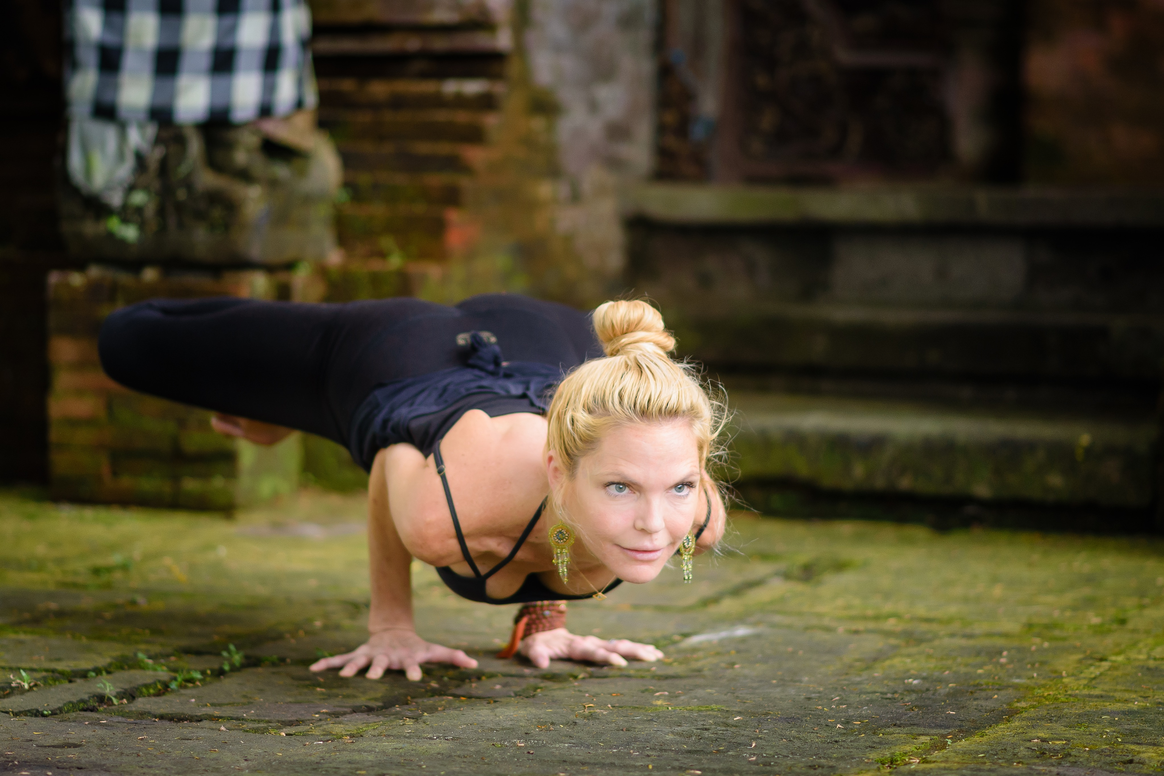
“Super Soul Flow” / Vinyasa Flow / Mantra & Japa / Meditation
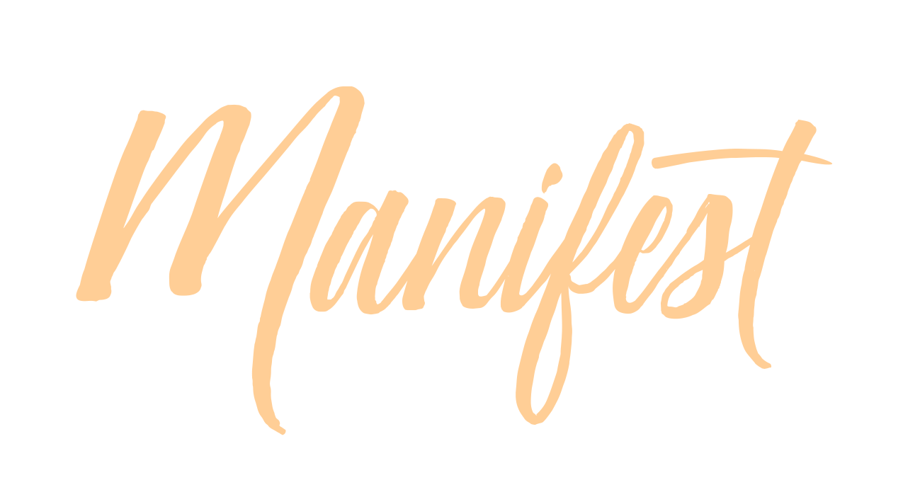
Suggested: 2-4 Hours
All levels welcome / Hours good for Yoga Alliance CE’s & THY 200/300Hr TT
Get ready to connect to your SUPER SOUL! A challenging yet approachable for all levels Vinyasa Flow based workshop supported by one of Tymi's world-renowned playlists. Tymi will take you on a yoga adventure that will stoke the inner fires of your body, mind, and SPIRIT! Release self-doubts, limiting belief patterns and habits and abandon fears that block you from reaching your highest potential in this lifetime! Starting with setting a Sankalpa, Mantra/Japa, and then transitioning into an asana practice that will tap into your deep core power, open your heart and free your mind to the unlimited potential of your Super Soul! Be prepared to surprise yourself and leave feeling completely empowered. Foundational standing asanas, Inversions (and modifications), Handstands (options/modifications), Backbends (and variations), a juicy floor sequence, final rest and short meditation.

“Rock the Bhakti” / Vinyasa Flow / Kirtan / Deities / Meditation
Suggested: 2-4 Hours
All levels welcome / Hours good for Yoga Alliance CE’s & THY 200/300Hr TT
*All Levels Welcome / Hours good for CE's with Yoga Alliance & THY 200/300Hr TT
One of Tymi's signature workshops, Rock the Bhakti is a celebration of Love, Service, and Devotion. A nondogmatic, Bhakti inspired vinyasa flow based workshop artfully sequenced to both contemporary and kirtan beats. Learn about some of the foundational Deities in the Bhakti tradition and then start to stoke your internal flame with a short kirtan (call and response) that will open you up to the very heart of your practice. Transitioning into asana, we will send out a direct message to the Universe that we are ready to take action, and responsibility as co-creators of our life story. Learn how to intelligently and efficiently open the shoulders, chest, and spine to experience the power of the Anahata (Heart) Chakra. When the heart opens it literally becomes "unstruck" and we are able to experience the flow of unconditional love. Not to leave out the lower body, we will also dive into quad, psoas, hamstring, and hip releases. You will most definitely sweat, sing, laugh and when the spirit moves dance!

“Manifest Flow!” / Vinyasa Flow, Japa/Mantra, Meditation
Suggested: 2-4 Hours
All levels welcome / Hours good for Yoga Alliance CE’s & THY 200/300Hr TT
When we plant our seed of Sankalpa (heartfelt intention and purpose) deep within our subconscious mind It becomes a powerful tool of manifesting what we want in our lives. When we consciously connect our Sankalpa with our asana practice it sends a direct message to the Universe that we are ready to take action and the Universe will rise up to support us. We become co-creators and manifest artists to the world in which we live. This very special workshop is a fusion created by Tymi using a Sankalpa / intention setting exercise, pranayama, Japa/Mantra, Asana (Vinyasa Flow) and ending with a short Yoga Nidra.

“The Dance of Shiva & Shakti” / Vinyasa Flow/Yin Yoga
Suggested: 2-3 Hours
All levels welcome / Hours good for Yoga Alliance CE’s & THY 200/300Hr TT
Experience the Yin/Yang factor in this perfectly balanced 2 hour Vinyasa and Yin Yoga practice. A one hour heat building detoxifying flow increasing prana and energy through the body, followed by a 1 hour yin practice, focusing on the connective tissue and fascia. The Vin / Yin combo allows us to dive deep into unexplored layers of tension and patterns of holding in the body, releasing our issues from all our tissues. By working both feminine and masculine, yin and yang, muscular and organic aspects of our being, we provide a "holistic" and whole body healing. Float off your mat feeling balanced and blissed out!

“Unravel & Unwind” / Myofascial, Vinyasa & Yin
Suggested: 2-3 Hours
All levels welcome / Hours good for Yoga Alliance CE’s & THY 200/300Hr TT
Learn how to Unravel and Unwind your entire body through the artistic fusion of Myofascial Release, Vinyasa Flow & Yin Yoga. Starting from our very connection to the Earth, our feet and working our way up the body systematically targeting the major joints and muscle groups. By opening those “stuck” areas of the body, you will experience newfound spaciousness and freedom. Expect to learn how to use your own body for myofascial release, effortlessly flow into a vinyasa practice building some heat and targeting the muscles, and then winding it all down with a blissful yin yoga practice targeting the complete fascial system. 1 Tennis, Lacrosse, or Myofascial ball needed.

“The Power of Stillness” / Yin Yoga & Yoga Nidra
Suggested: 3 Hours
All levels welcome / Hours good for Yoga Alliance CE’s & THY 200/300Hr TT
A 3 Hour Yin & Nidra Workshop we will dive deep into the body and mind using an artistically woven and challenging Yin Yoga practice followed by a Yoga Nidra. Yin Yoga targets the connective tissues, such as the ligaments, bones, and even the joints of the body that normally are not exercised very much in a more active style of asana practice. Suitable for almost all levels of students, Yin Yoga is a perfect compliment to the dynamic and muscular (yang) styles of yoga that emphasize internal heat, and the lengthening and contracting of our muscles. Yin Yoga generally targets the connective tissues of the hips, pelvis, and lower spine. While initially, this style of yoga can seem quite boring, passive, or soft, yin practice can be quite challenging due to the long duration of the poses. We can remain in the postures anywhere from one to twenty minutes! Yin and yang tissues respond quite differently to being exercised. You need to experience this to really know what Yin Yoga is all about. After you have experienced it, even just once, you will realize that you have been doing only half of the asana practice.

“Foundations of Flight” / Inversions for Beginners
Suggested: 2-4 Hours
All levels welcome / Hours good for Yoga Alliance CE’s & THY 200/300Hr TT
Let’s strip it down and focus our attention solely on being upside down. In this workshop, we will investigate a multitude of aspects that allow us to hold a safe and stable arm balance and headstand. The feet, the hips, the core, the shoulder girdle, the wrists and hands all play an important role in getting and staying upside down. We’ll open, strengthen and integrate through an intelligent flow of foundational poses to build the strength and body awareness needed to fly. We may incorporate wall-work, partner work, and ultimately move towards solo flight. All levels are welcome. Variations and modifications will be given to beginners and frequent flyers alike.

“Yoga Playground!” / The Creative Art of Assisting and Adjustments Immersion
Suggested: 6 Hours
All levels welcome / Hours good for Yoga Alliance CE’s & THY 200/300Hr TT
Join Tymi for a full day of exploring and workshopping adjustments, modifications, assists & creative options in the yoga asanas. Immersion includes a 2 Hour Vinyasa Yoga practice followed by 4 hours of workshop time for yoga teachers & students; this immersion is open to ALL. We will discuss the 4 main methods of adjusting, energetic etiquette, practice assist's in many different poses including but not limited to foundational standing asanas, sun salutations, floor work, inversions, Thai & partner variations and also take time for Q&A.

The goal of this workshop is to inspire and cultivate a better understanding of how to intuitively and safely assist the student in discovering more freedom, bliss and deeper expression of an asana. By understanding the biomechanics of the poses and trusting your intuitive instincts a student and teacher can deepen their practice through creative, fun exploration of the asana.

“The Art of Assisting & Adjustments” / Workshop
Suggested: 6 Hours
All levels welcome / Hours good for Yoga Alliance CE’s & THY 200/300Hr TT
Creative (& Intuitive) Assisting & Adjustments for Yoga Teachers, but open to the ALL. We will discuss the 4 main methods of adjusting, energetic etiquette, practice assist's in many different poses and take time for Q&A. The goal of this workshop is to gain a better understanding of how to properly and safely assist the student in discovering more freedom, bliss and deeper expression of an asana. By understanding the biomechanics of the poses a student and teacher can deepen their practice through the creative exploration of the asanas.

Yin Yoga Immersion/ Training/ Part 1/ One Day Intensive
Suggested: 5-6 Hours (Includes 2 Hr Yin Class that can be sold separately)
Yin yoga is not a trademarked system and no certification is required to teach it, but for those interested in learning the anatomic and energetic theories of the practice we are doing a one day intensive that can be used as 4-6 CEU's with Yoga Alliance. You will receive a certificate of completion.

Go Deeper! Yin Yoga challenges you to explore your hips and spine more fully than you could have imagined. Dive even deeper into understanding the Yin Yoga system in this Yin Yoga Intensive Training Course. You will learn which tissues are being targeted, the physiological benefits of practicing in a yin fashion, and the subtle effects that contribute to the all-over good feeling the practice creates. We will investigate more than 25 Yin Yoga poses, learning individual-specific alignment as well as the energy channels being stimulated. You will viscerally integrate the information so that, upon completing the course, you will be able not only to teach Yin Yoga classes but also to answer students' questions with confidence and clarity.

Topics of Study:
• Three Tattvas of Yin Yoga
• Distinctions between yin and yang
• Vital difference between tension and compression
• Yin Yoga's alignment considerations: proportion, appropriate stressing of tissue, and when to back off
• Energy flow, meridians/nadis, and how to cultivate balance
• Considerations for sequencing Yin Yoga classes.

Yin Yoga Immersion/ Training/ Part 2/ One Day Intensive
Suggested: 5-6 Hours (Includes 2 Hour Yin Yoga on the Rocks Practice, which can be sold separately)
Yin yoga is not a trademarked system and no certification is required to teach it, but for those interested in learning the anatomic and energetic theories of the practice we are doing a one day intensive that can be used as 6 CEU's with Yoga Alliance. You will receive a certificate of completion.

Go even deeper, tap into more creativity and explore in greater detail the art of Yin Yoga. This training will challenge you to explore your hips and spine more fully than you could have imagined. Dive even deeper into understanding the Yin Yoga system in this Yin Yoga one day intensive training course that builds on Part 1 "Foundations of Yin Yoga" You will review which tissues are being targeted, the physiological benefits of practicing in a yin fashion, and the subtle effects that contribute to the all-over good feeling the practice creates. We will investigate more than 25 Yin Yoga poses and variations. We will begin to incorporate the feet, wrists, block work and some myofascial release using the body. Reviewing and learning individual-specific alignment as well as the energy channels being stimulated. You will viscerally integrate the information so that, upon completing the course, you will be able to practice and teach the art of Yin Yoga from a creative, intuitive and knowledgeable foundation.

Review:
The 3 Tattvas of Yin Yoga
• Distinctions between yin and yang
• Vital difference between tension and compression
• Yin Yoga's alignment considerations: proportion, appropriate stressing of tissue, and when to back off
• Energy flow, meridians/nadis, and how to cultivate balance

New Materials:
• Incorporating Blocks and Myofascial Release Techniques
• Considerations for sequencing Yin Yoga classes
• Theming a Yin Practice & Music
• Assessing your "Audience
• Creating 60 minute, 90 minute, 2 hour, and Vin/Yin classes.
• Assisting, Adjusting & Props • Modifications & Teaching to special cases

This training will INSPIRE & EMPOWER you to practice and teach safe, effective, and compassionate Yin Yoga classes with creativity and skill. It is appropriate for dedicated students of Yin Yoga and teachers of all traditions.

“The Power of Stillness”/ Yin Yoga & Yoga Nidra
Suggested: 3-4 hour
All levels welcome / Hours good for Yoga Alliance CE’s & THY 200/300Hr TT
A 3 Hour Yin & Nidra Workshop we will dive deep into the body and mind using an artistically woven and challenging Yin Yoga practice followed by a Yoga Nidra. Yin Yoga targets the connective tissues, such as the ligaments, bones, and even the joints of the body that normally are not exercised very much in a more active style of asana practice. Suitable for almost all levels of students, Yin Yoga is a perfect compliment to the dynamic and muscular (yang) styles of yoga that emphasize internal heat, and the lengthening and contracting of our muscles. Yin Yoga generally targets the connective tissues of the hips, pelvis, and lower spine. While initially, this style of yoga can seem quite boring, passive, or soft, yin practice can be quite challenging due to the long duration of the poses. We can remain in the postures anywhere from one to twenty minutes! Yin and Yang tissues respond quite differently to being exercised. You need to experience this to really know what Yin Yoga is all about. After you have experienced it, even just once, you will realize that you have been doing only half of the asana practice.

“Strength, Flexibility & Balance!" / Subtle Anatomy & Chakras
1/2 or Full Day Immersion
Suggested: 4-6 Hours
All levels welcome / Hours good for Yoga Alliance CE’s & THY 200/300Hr TT
Dive into and learn all about the Subtle Anatomy, systems of the body and 7 Main Chakras, followed by a 3 Hour Vinyasa, Yin Yoga and Meditation practice. Experience the powerful balancing effects of this complete practice focused on the different energetic principles and elements of the 7 main Chakras. Learn the aspects and qualities of each Chakra beginning at the Root (Muladhara) Chakra and working our way up to the Crown (Sahasrara) Chakra. Immersion will include handouts, lecture, asana (both vinyasa & yin based) and meditation practice.
Recommended Props: Yoga mat, 2 blocks, strap, blanket

“The Dance of Shiva & Shakti” | Vinyasa Flow & Yin Yoga
Suggested: 2 Hours
All levels welcome / Hours good for Yoga Alliance CE’s & THY 200/300Hr TT
Experience the Yin/Yang factor in this perfectly balanced two hour Vinyasa and Yin Yoga practice. A one hour heat building detoxifying flow increasing prana and energy through the body, followed by a 1 hour yin practice, focusing on the connective tissue and fascia. The Vin / Yin combo allows us to dive deep into unexplored layers of tension and patterns of holding in the body, releasing our issues from all our tissues. By working both feminine and masculine, yin and yang, muscular and organic aspects of our being, we provide a "holistic" and whole body healing. Float off your mat feeling balanced and blissed out!

“Malas, Mantra, Mediation & Sankalpa!”
Suggested: 2 Hours (Not a physical practice)
All levels welcome / Hours good for Yoga Alliance CE’s & THY 200/300Hr TT
Sankalpa (Sanskrit: संकल्प) means an intention formed by the heart and mind -- a solemn vow, determination, or will.What is the primary purpose of your life? You will learn to align fully with what is happening in the present moment and discuss the ancient yogic concepts of Japa, Mantra, and Mediation and how to use them in your life today for health, healing and discovery of your life purpose (dharma). Release old thought patterns, limited beliefs, habits, and conditioning, and embrace the beauty of effortless being. Each student will receive their own Mala (from Bali Malas) along with Tymi's "Mala's Mantra, Meditation & Sankalpa" study guide packed with theory, philosophy, mantras, and worksheets. We will go over the meaning, symbolism, and significance of the 108 beads/seeds of the Mala. Practice will involve setting a personal sankalpa, cleansing, charging and using the mala for japa, mantra, and deep meditation. This workshop involves lecture, discussion, mediation, japa, an open mind and brave heart. WEAR COMFORTABLE CLOTHING. Workshop includes a personal practice mala from Bali Malas and a handout of "Malas, Mantra & Meditation” by Tymi Howard.

"Kundalini Rising!" / Subtle Anatomy, Chakras, and Unraveling Samsakaras
Suggested: 2-3 Hours (Lecture and Discussion. No Physical Asana)
All levels welcome/Hours good for Yoga Alliance CE’s & THY 200/300Hr TT
Demystifying the psychic energy of the subtle anatomy of the body. Dive into discussions about Yoga Nadis, Prana, Chakras, Samskaras, and how we can apply this knowledge into our everyday lives. Learn tools to awaken the dark unexplored areas and blockages of our lives and bodies. Discover where we might need to cultivate more balance, and what we can actively do to achieve it.

"Lifestyle Foundations of a Modern Day Yogi"
Suggested: 2-3 Hours (Lecture and Discussion. No Physical Asana)
All levels welcome/Hours good for Yoga Alliance CE’s & THY 200/300Hr TT
How do we take the very ancient tools of yoga, and apply them to our very different modern day lifestyle? How can we respect tradition and yet still honor ourselves, our families and function from a place of compassion, tolerance and balance? We will study the eight limbs of yoga, and how we can apply them to our current day schedules and lives. We will discuss the Yamas and Niyamas from both a classical and tantric viewpoint, and how they connect to all the many facets of our lifestyle choices. Discussing everything from personal and professional relationships, to nutrition and diet. We will touch base on the Koshas and Gunas, and how we transition through the different layers of understanding and attachment in reference to the Yoga Sutras and Bhagavad Gitta.

“Holy Hot Vinyasa!” / Creative FUN Vinyasa Flow Yoga
All levels welcome / Hours good for Yoga Alliance CE’s & THY 200/300Hr TT
This challenging and creatively sequenced specialty class is for the yogi who desires more than what the standard yoga class offers. Burn away all the obstacles that clutter the mind and fog the mirror of the soul. Wring out the toxic emotions that build up and stagnate within the body. It has been our direct experience that an intense asana practice and deep stretching/ opening poses will bring about these changes. Practitioner should have a good working knowledge of backbends, headstands and inversions

"Holy Hanuman!" / Hamstrings & Hips
All levels welcome / Hours good for Yoga Alliance CE’s & THY 200/300Hr TT
Get ready to take that leap... connecting to your inner "Super Hero" (Hanuman). You will learn how to intelligently and efficiently open the Hamstrings and Hips creating space and freedom in the body. Stirring up the Shakti and tapping into our most creative energy pool in the body! This vinyasa based practice will begin with a flowing standing sequence followed by a long juicy floor section. Be prepared to go 360 degrees around the hips and hamstrings.

“Gratitude Flow”/ Heart Openers, Backbends & Variations
All levels welcome / Hours good for Yoga Alliance CE’s & THY 200/300Hr TT
Open up to the heart of your practice. Learn how to intelligently and efficiently open the shoulders, chest, heart and spine to experience the power of the Anahata Chakra. As our hearts open they literally become "unstruck" and we are able to experience the flow and grace of life as pure bliss. This vinyasa practice will include a flowing standing sequence, quad/ psoas release and then move into shoulder and heart opener variations. A loving, strong and powerful flowing practice.

"Hot, Hip & Holy!” Hot: Heated (Warm) Room, Let's Sweat!
“Holy Hot Vinyasa!” / Creative FUN Vinyasa Flow Yoga
All levels welcome / Hours good for Yoga Alliance CE’s & THY 200/300Hr TT
This challenging and creatively sequenced specialty class is for the yogi who desires more than what the standard yoga class offers. Burn away all the obstacles that clutter the mind and fog the mirror of the soul. Wring out the toxic emotions that build up and stagnate within the body. It has been our direct experience that an intense asana practice and deep stretching/ opening poses will bring about these changes. Practitioner should have a good working knowledge of backbends, headstands and inversions

“Beautifully Blissed Out” / Yin Yoga
All levels welcome / Hours good for Yoga Alliance CE’s & THY 200/300Hr TT
A 90 minute Deep Yin Practice, artistically woven and challenging followed by a 30 minute Yoga Nidra. All Levels Welcome. Yin Yoga targets the connective tissues, such as the ligaments, bones, and even the joints of the body that normally are not exercised very much in a more active style of asana practice. Suitable for almost all levels of students, Yin Yoga is a perfect compliment to the dynamic and muscular (yang) styles of yoga that emphasize internal heat, and the lengthening and contracting of our muscles. Yin Yoga generally targets the connective tissues of the hips, pelvis, and lower spine. While initially this style of yoga can seem quite boring, passive, or soft, yin practice can be quite challenging due to the long duration of the poses. We can remain in the postures anywhere from one to twenty minutes! Yin and yang tissues respond quite differently to being exercised. You need to experience this to really know what Yin Yoga is all about. After you have experienced it, even just once, you will realize that you have been doing only half of the asana practice. Yoga Nidra is an ancient but little-known yogic practice that's becoming increasingly popular as both a form of meditation and a mind-body therapy. It is a systematic form of guided relaxation, yogic sleep is a state of consciousness between waking and sleeping, like the "going-to-sleep" stage. ... The yogic goal of both paths, deep relaxation (yoga nidra) and meditation are the same, a state called samadhi.

“Vin-Yin”/ 1/2 Vinyasa & 1/2 Yin
All levels welcome / Hours good for Yoga Alliance CE’s & THY 200/300Hr TT
Experience the Yin/Yang factor in this perfectly balanced 2 hour practice. A one hour Vinyasa Flow practice that builds heat and gets prana/energy flowing through the body, followed by a 1 hour Yin practice, focusing on the connective tissue and fascia. Vin Yin allows us to dive deep into unexplored layers of tension and patterns of holding in the body. Float off your mat feeling balanced and blissed out!

“LILA! Yoga Playground” / Vinyasa with Inversions
All levels welcome / Hours good for Yoga Alliance CE’s & THY 200/300Hr TT
LILA! Let's PLAY...Approaching our yoga practice with a childlike sense of exploration and wonder, helps us face our fears from of a place of discovery. Release the grip that causes us to remain stagnant in our practice and life. Turn upside down and all around with back bends, headstands, handstands and creative variations in a mindful and approachable way, that will leave you feeling empowered and inspired. Can you hear the music?

“Dancing Gravity with Grace” / Arm Balances, Inversions & Core
All levels welcome / Hours good for Yoga Alliance CE’s & THY 200/300Hr TT
This challenging playful workshop class is for the yogi who desires more than what the standard yoga class offers. Tap into your deep core, move and flow from your center and stand true in your power with grace. We will tap into our deep core connections, wake up & strengthen the upper body as we learn exercises & variations that will help build awareness to safely and skillfully practice crow (and various transitions), headstands, handstands, forearm balances and creative fun variations.
Come ready to tap into your true power, flow with grace and dance with gravity! Please bring a block.

"Bhakti Bash!" / Devotional Vinyasa Flow
All levels welcome / Hours good for Yoga Alliance CE’s & THY 200/300Hr TT
A Vinyasa Flow Class & Bhakti Music celebration! A non dogmatic, inspired and spirit filled flow practice supported by contemporary and kirtan beats. You will most definitely sweat, sing, laugh and when the spirit moves, dance!
This is my signature class, not to be missed....be in the bhav, as we cultivate the BHAKTI LOVE!

“YIN ROCKS!”
All levels welcome / Hours good for Yoga Alliance CE’s & THY 200/300Hr TT
The Yin Yoga practice is subtle, and deep, and its physical purpose is to work beyond the muscle tissue delving into the connective tissues, tendons, ligaments, bones, cartilage and the deepest facia networks in the body. The physical and emotional releases are Omazing! Yin on the Rocks is a creatively sequenced 2 Hour Yin Yoga practice that offers options to kick up the effects of each pose, all set to contemporary Rock Music!

BHAKTI YOGA IMMERSION
OR TEACHER TRAINING • 20 HOUR IMMERSION
Module 1 good for 20 Hours of Yoga Alliance CE’s or 20 hours can be used towards THY 200/300Hr TT
An in-depth study of the foundations of Bhakti, Bhakti Vinyasa Yoga, and Kirtan.
The Bhakti Yoga Immersion/ Teacher Training is a rich, diverse, soulful and comprehensive program for everyone, including yoga teachers looking to broaden their current skills, aspiring teachers and serious yet playful students of Yoga, Vinyasa Flow Yoga, and Kirtan. In honoring the ancient tradition and art of Yoga, Bhakti, the path of love, devotion and service. This 20 Hour course will provide a strong foundation and clear techniques for the student of yoga to go deeper, a student to transform their practice into a teacher of yoga, as well as those currently teaching yoga will root themselves deeply in the philosophy and techniques of Bhakti.

In the spirit of service to humanity, the participant will be encouraged to offer themselves as a healing and uplifting presence to the world. This heart-based joyful program offers an opportunity for students to deepen their own yoga practice, practice teaching Bhakti Yoga classes, incorporate music, creative sequencing and pose variations, study philosophy and share the blessings of bhakti yoga and satsang in a very loving and supportive atmosphere.

Topics of study for full 20 hour training:
- Asana/pranayama/meditation/vinyasa
- Art of vinyasa yoga sequencing
- How to teach(and practice teaching) a bhakti vinyasa flow yoga class
- How to integrate bhakti, kirtan, mantra, and philosophy into a vinyasa yoga clas
- How to lead kirtan and incorporate music into their practice and teachings (no previous musical experience necessary)
- Meanings of mantras and a deeper exploration of the Gods/Goddesses from the bhakti tradition
- Study of the sacred teachings/texts: Bhagavad Gita, Yoga Sutra of Patanjali
- Ayurveda and the science of self-healing

50 Hour Yin Yoga Immersion and Teacher Training
Hours good for Yoga Alliance CE’s & THY 200/300Hr TT
This training will INSPIRE & EMPOWER you to practice and safely teach effective and compassionate Yin Yoga classes with creativity and skill. It is appropriate for dedicated students and teachers of all yoga traditions.

Overview:
- Japa, Pranayama & Meditation
- Where did Yin originate, who? and why practice Yin?
- Philosophy, Theory, Physiology
- Principles of Practicing Yin Yoga
- Nadis, Prana, Tattvas
- Subtle Anatomy Review & Koshas, Gunas, 3 Main Nadis
- Overview of Foundational Yin Poses
- Class Themes, Focus & Grouping
- Chakras & Chakra Balancing
- Teaching Asanas, Principles of Adjusting
- Adjusting & Modification
- Energetic Centers
- Sharing Sequences, Creating Sequences, Practice Teaching
- Myofascial Release, Roll & Release

Yin Yoga challenges you to explore all of your joints, especially the hips and spine more fully than you could have imagined. Dive even deeper into understanding the Yin Yoga system in this 10 hour Yin Yoga 2 Day Intensive Training Course. You will learn which tissues are being targeted, the physiological benefits of practicing in a yin fashion, and the subtle effects that contribute to the all-over good feeling the practice creates. We will investigate more than 25 Yin Yoga poses, learning individual-specific alignment as well as the energy channels being stimulated. You will viscerally integrate the information so that, upon completing the course, you will be able not only to skillfully practice Yin Yoga, but also teach Yin Yoga classes and answer students’ questions with confidence and clarity.

Premise: Yin Yoga has the same goals and objectives as any other school of yoga; however, it directs the stimulation normally created in the asana portion of the practice deeper than the superficial or muscular tissues (which we are calling the yang tissues). Yin Yoga targets the connective tissues, such as the ligaments, tendons, bones, and even the joints of the body that normally are not exercised very much in a more active style of asana practice.

Suitable for almost all levels of students, Yin Yoga is a perfect compliment to the dynamic and muscular (yang) styles of yoga that emphasize internal heat, and the lengthening and contracting of our muscles. Yin Yoga generally targets the connective tissues of the hips, pelvis, and lower spine. We will also be focusing on the shoulders, wrists, ankles and feet.

While initially this style of yoga can seem quite boring, passive, or soft, yin practice can be quite challenging due to the long duration of the poses. We can remain in the postures anywhere from one to twenty minutes! Yin and yang tissues respond quite differently to being exercised.
You need to experience this to really know what Yin Yoga is all about. After you have experienced it, even just once, you will realize that you have been doing only half of the asana practice.

Please note: Yin Yoga is not restorative yoga. Like all yoga practices, if the tissues you are targeting for exercise are damaged in some way, please give yourself a chance to heal before resuming your regular practice.

What you will need:
Journal & Pen
*Mala /(if you have one)
Mat
2 Blocks
Blanket
Strap
Bolster
50 Hour Yin Yoga Manual
**(included in training)
Example of Schedule:

Day 1
Japa, Pranayama & Meditation
Introductions, “My Story”, Where did Yin originate, Who? and why practice Yin?
1 Hour Yin Practice
Lunch
Lecture: Philosophy, Theory, Physiology of Yin Yoga.
Master Yin Yoga Practice

Day 2:
Japa, Pranayama & Meditation
Principles of Practicing Yin Yoga, Nadis, Prana, Tattvas, 1 Hour Yin Practice
Lunch
Lecture: Principles of Teaching Yin Yoga
Practice Yin Yoga

Day 3
Japa, Pranayama & Meditation
Subtle Anatomy Review & Koshas, Gunas, 3 Main Nadis.
1 Hour Yin Practice
Lunch
Lecture: “List and Overview of Foundational Yin Poses”Practice Yin Yoga
Master Yin Yoga Practice

Day 4
Japa, Pranayama & Meditation
Lecture: Class Themes, Focus & Grouping.
1 Hour Yin Practice
Lunch
Lecture: Chakras & Chakra Balancing
Master Yin Yoga Practice

Day 5
Japa, Pranayama & Meditation
Teaching Asanas, Principles of Adjusting in Yin Yoga.
1 Hour Yin Practice
Lunch
Lecture & Discussion: Adjusting & Modification Options in Yin Yoga Part 1.
Master Yin Yoga Practice

Day 6
Japa, Pranayama & Meditation
Lecture Energetic Centers, Adjusting & Modifications Part 2.
1 Hour Yin Practice
Lunch
Lecture & Discussion: Sharing Sequences, Creating Sequences and Myofascial Release.
Master Practice Yin Yoga & “Roll & Release”

