Tymi Howard Bio
TYMI HOWARD, 500 E-RYT with Yoga Alliance, is an international yoga teacher,
certified holistic coach, creator of Manifest Yoga International and founder of Guruv Yoga Studios in the United States. Pioneering the Vinyasa and Yin Yoga movement not only in Central Florida, but throughout mainland China, SE Asia, and Indonesia. Tymi is dedicated to inspiring people to discover their life's purpose through the art of yoga. Her introduction to yoga began in NYC in 1993 as a professional ballet dancer with several nagging injuries and she found her way into an Ashtanga class. Receiving her BA in Theatre and Dance from Rollins College and Masters Degree from NYU/ Circle in the Square, and Yoga Trainings with John Friend, Dharma Mittra, David Swenson, Steve Ross, Jonny Kest, Barron Baptiste, Shiva Rea, David Life and Sharon Gannon just to name a few. Tymi considers herself to be a "professional student.”Tymi is known in the yoga community as a "Teacher of Teachers" and a skilful graceful practitioner. Students fall in love with her dynamic, playful style of teaching, artistic sequencing and music! Self-proclaimed travel junky, blogger and animal
rights advocate, she is a lover of God, Life and Yoga. Tymi is forever a student and
grateful to all of her teachers, students, and family who continue to inspire! You can
join Tymi around the globe for one of her Yoga Alliance Certified Trainings,
Workshops, Retreats or at a conference and festival. Online Classes can currently
be found on DailyYoga and Yogavibes.
Website: www.tymihoward.com

Tymi Howard Shorten Bio
TYMI HOWARD, 500 E-RYT with Yoga Alliance, is an international yoga teacher.
Pioneering the Vinyasa and Yin Yoga movement not only in Central Florida,
but throughout mainland China, Indonesia and other parts of Asia. Tymi is dedicated
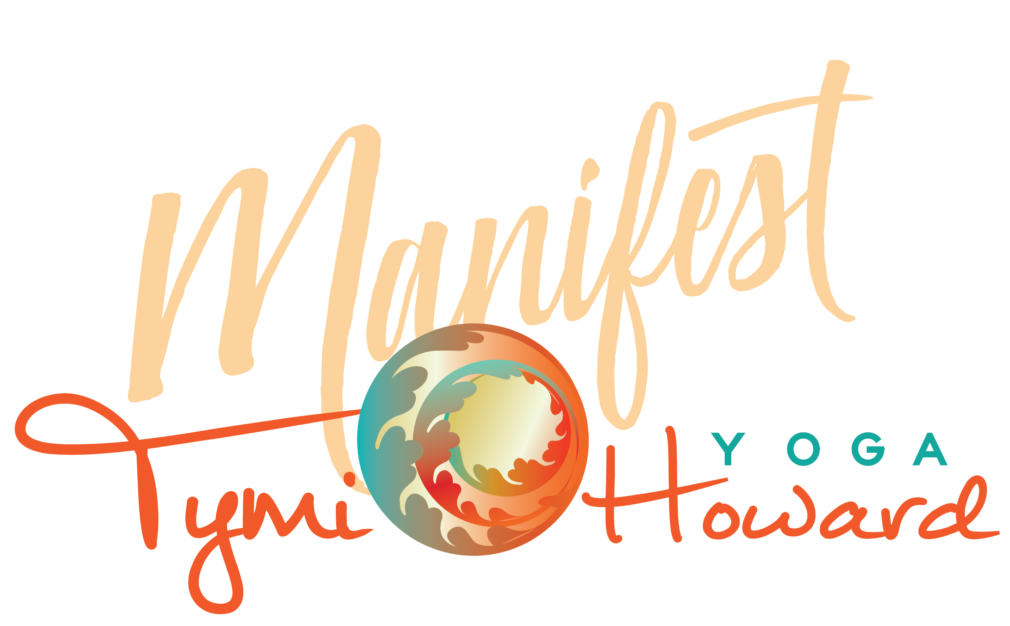
to inspiring people to discover their life's purpose through the art of yoga.

