MALAS, MANTRA & MEDITATION

MALAS (Sanskrit: mālā "garland")
Malas are a traditional tool used in the Buddhist tradition to count the number of times a mantra is recited, breaths while meditating, counting prostrations, or the repetitions of a buddha's name. If you are in the world of yoga, you know that malas are widely popular among aspirants, whatever spiritual path or belief system they practice. Just like anything, the most important part of owning and using a mala is the intention associated with it.

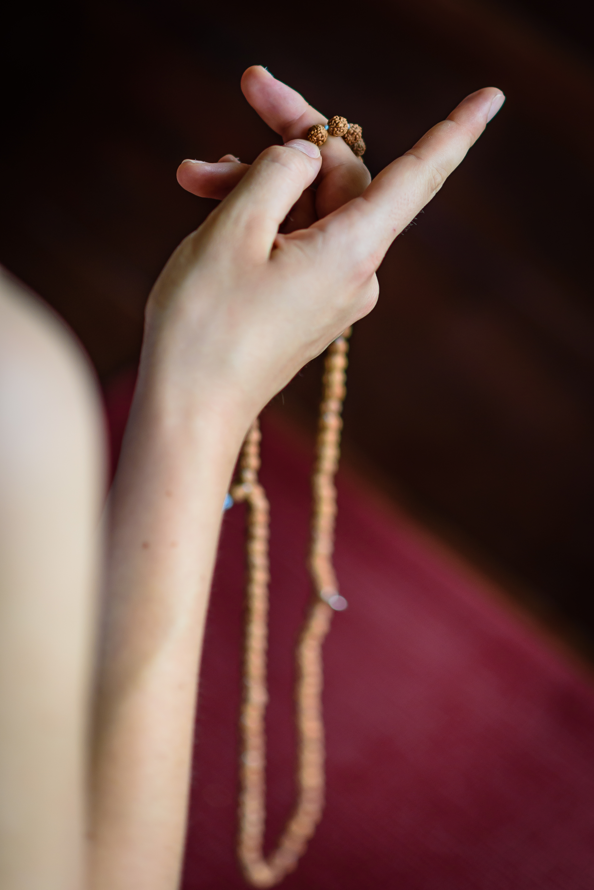
Symbolism of 108

On a mala, or set of mantra counting beads, there are generally 108 beads (seeds), or some fraction of that number. The question often arises: Why are there 108 beads on a mala?
Below are some of the many reasons, as well as a few other points of interest. None of these reasons are being promoted as more or less true than the others. However, you may notice that 108 appears to be somewhat like a road map of reality in general, and the human in particular.
Regardless of the meaning of 108, it is important that if a mala is used to count mantras, the mantra be remembered with sincerity, devotion, feeling, and full attention.
9 times 12: Both of these numbers have been said to have spiritual significance in many traditions. 9 times 12 is 108. Also, 1 plus 8 equals 9. That 9 times 12 equals 108.
Powers of 1, 2, and 3 in math: 1 to 1st power=1; 2 to 2nd power=4 (2x2); 3 to 3rd power=27 (3x3x3). 1x4x27=108
Harshad number: 108 is a Harshad number, which is an integer divisible by the sum of its digits (Harshad is from Sanskrit, and means "great joy“)
Desires: There are said to be 108 earthly desires in mortals.
Lies: There are said to be 108 lies that humans tell.
Delusions: There are said to be 108 human delusions or forms of ignorance.
Heart Chakra: The chakras are the intersections of energy lines, and there are said to be a total of 108 energy lines converging to form the heart chakra. One of them, sushumna, leads to the crown chakra, and is said to be the path to Self-realization.
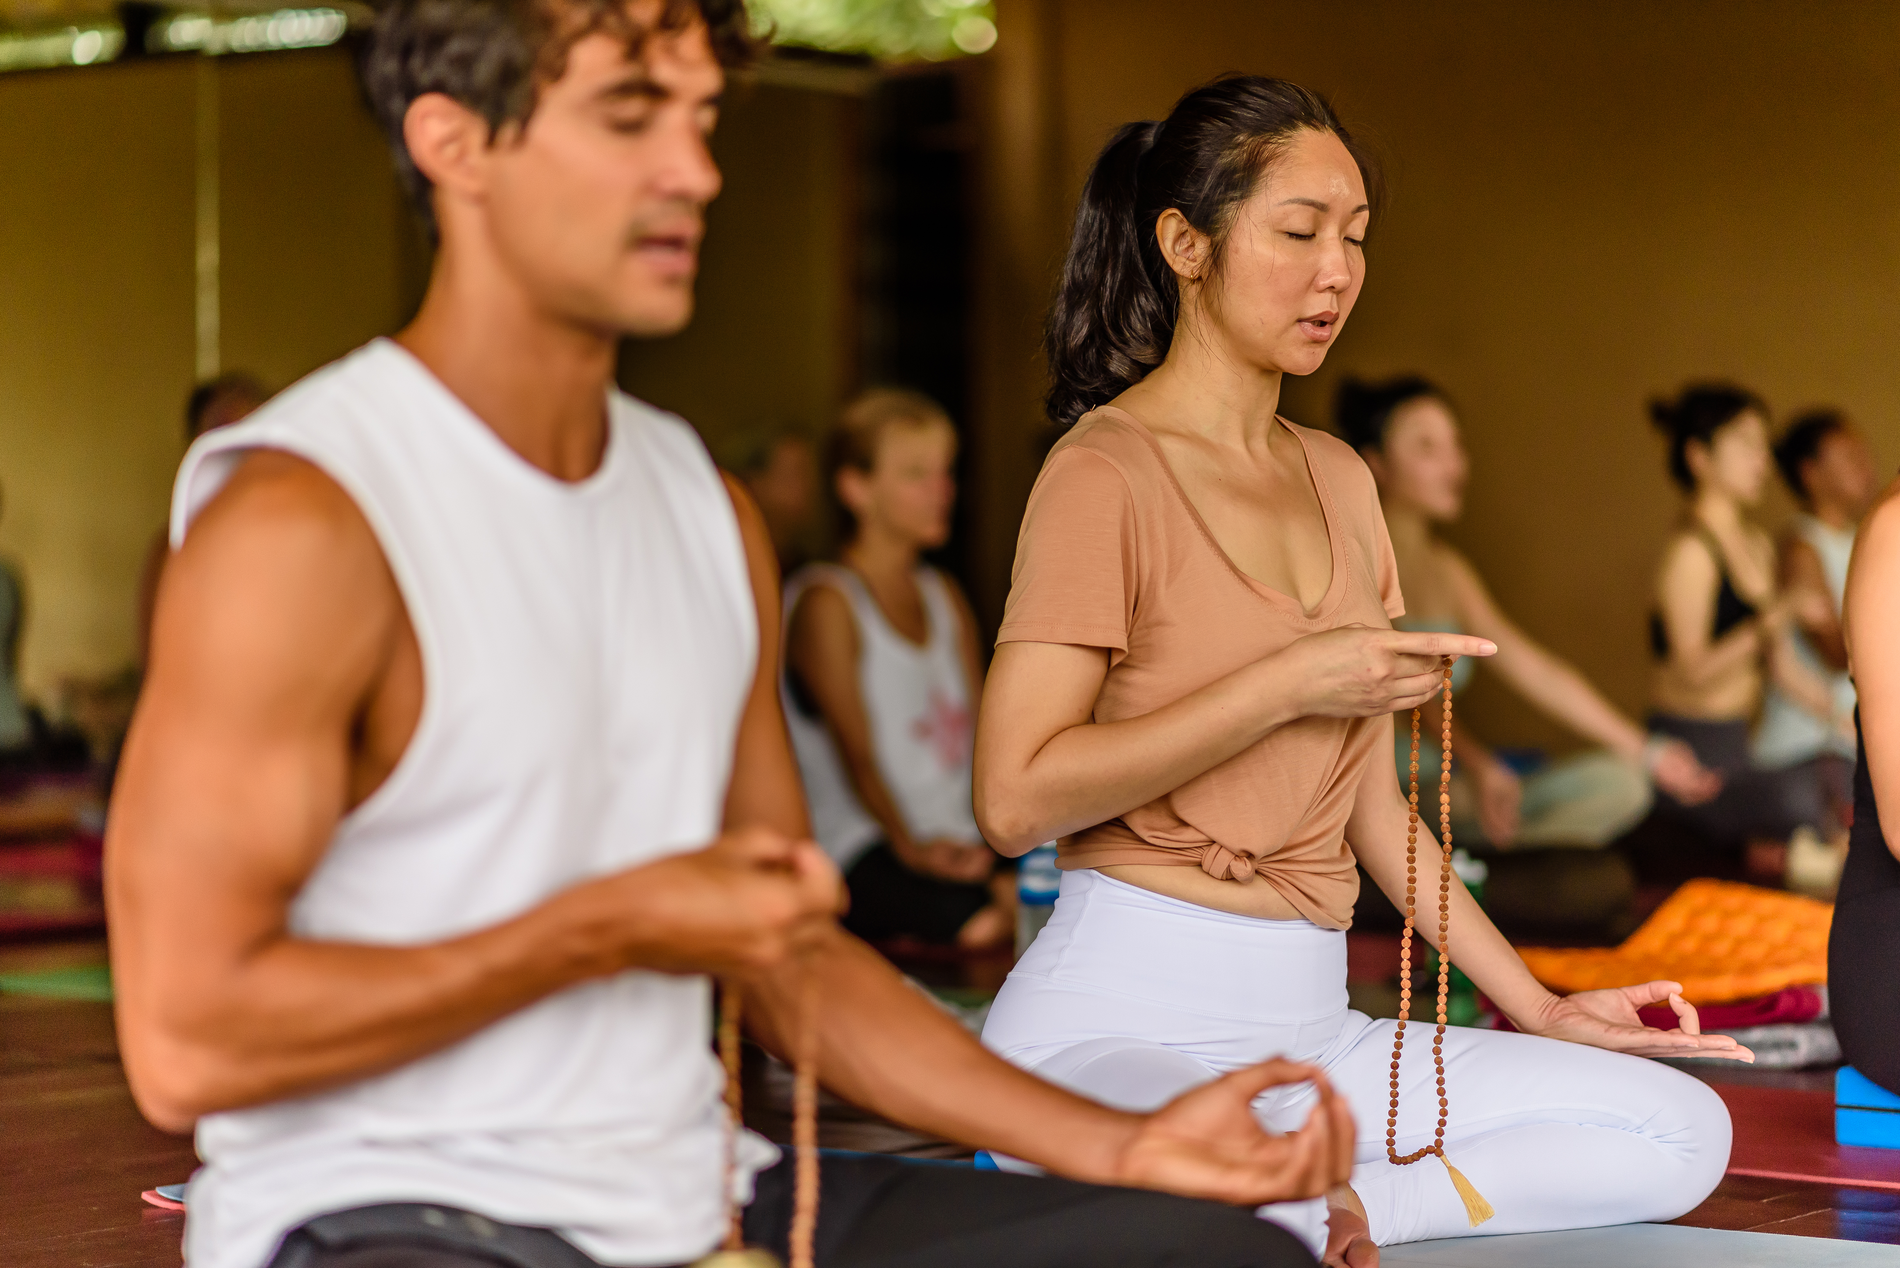
Sanskrit alphabet: There are 54 letters in the Sanskrit alphabet. Each has masculine and feminine, shiva and shakti. 54 times 2 is 108.
Pranayama: If one is able to be so calm in meditation as to have only 108 breaths in a day, enlightenment will come.
Upanishads: Some say there are 108 Upanishads, texts of the wisdom of the ancient sages.
Sri Yantra: On the Sri Yantra there are marmas where three lines intersect, and there are 54 such intersections. Each intersections has masculine and feminine, shiva and shakti qualities. 54 times 2 equals 108. Thus, there are 108 points that define the Sri Yantra as well as the human body.
Pentagon: The angle formed by two adjacent lines in a pentagon equals 108 degrees.
Marmas: Marmas or marmasthanas are like energy intersections called chakras, except have fewer energy lines converging to form them. There are said to be 108 marmas in the subtle body.
Time: Some say there are 108 feelings, with 36 related to the past, 36 related to the present, and 36 related to the future.
8 extra beads: In doing a practice of counting the number of repetitions of the mala, 100 are counted as completed. The remaining are said to cover errors or omissions. The 8 are also said to be an offering to God and Guru.
Chemistry: Interestingly, there are about 115 elements known on the periodic table of the elements. Most of those, around or higher than the number 100 only exist in the laboratory, and some for only thousandths of a second. The number that naturally exist on Earth is around 100.
Astrology: There are 12 constellations, and 9 arc segments called namshas or chandrakalas. 9 times 12 equals 108. Chandra is moon, and kalas are the divisions within a whole.
River Ganga: The sacred River Ganga spans a longitude of 12 degrees (79 to 91), and a latitude of 9 degrees (22 to 31). 12 times 9 equals 108.
Planets and Houses: In astrology, there are 12 houses and 9 planets. 12 times 9 equals 108.
Goddess names: There are said to be 108 Indian goddess names.
Gopis of Krishna: In the Krishna tradition, there were said to be 108 gopis or maid servants of Krishna.
Sun and Earth: The diameter of the Sun is 108 times the diameter of the Earth. The distance from the Sun to the Earth is 108 times the diameter of the Sun.
Moon and Earth: The average distance of the Moon from the Earth is 108 times the diameter of the Moon.
Silver and the moon: In astrology, the metal silver is said to represent the moon. The atomic weight of silver is 108.
Numerical scale: The 1 of 108, and the 8 of 108, when added together equals 9, which is the number of the numerical scale, i.e. 1, 2, 3 ... 10, etc., where 0 is not a number.
Meditations: Some say there are 108 styles of meditation.
Breath: Tantra estimates the average number of breaths per day at 21,600, of which 10,800 are solar energy, and 10,800 are lunar energy. Multiplying 108 by 100 is 10,800. Multiplying 2 x 10,800 equals 21,600.
Paths to God: Some suggest that there are 108 paths to God.
Smaller divisions: The number 108 is divided, such as in half, third, quarter, or twelfth, so that some malas have 54, 36, 27, or 9 beads.
Hinduism: 108 is said to refer to the number of Hindu deities. Some say that each of the deities has 108 names.
Islam: The number 108 is used in Islam to refer to God.
Jain: In the Jain religion, 108 are the combined virtues of five categories of holy ones, including 12, 8, 36, 25, and 27 virtues respectively.
Sikh: The Sikh tradition has a mala of 108 knots tied in a string of wool, rather than beads.
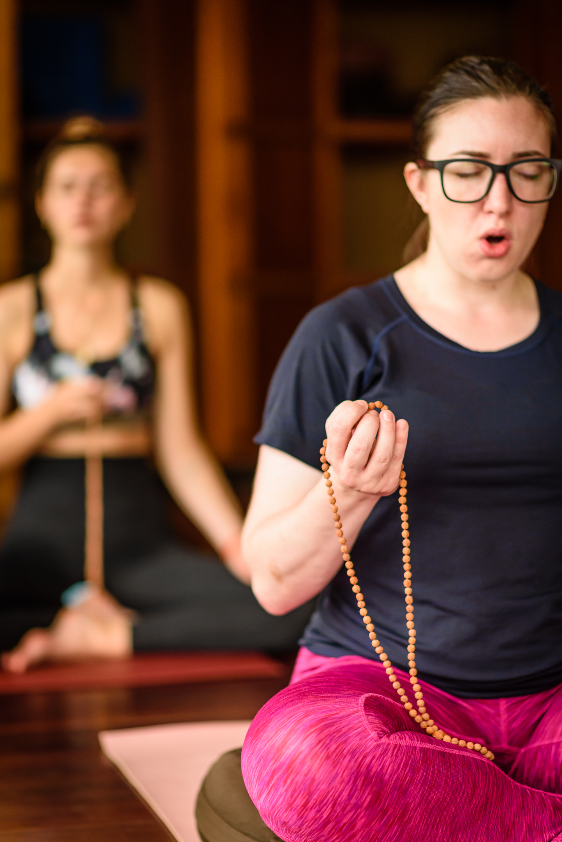
Buddhism: Some Buddhists carve 108 small Buddhas on a walnut for good luck. Some ring a bell 108 times to celebrate a new year. There are said to be 108 virtues to cultivate and 108 defilements to avoid.
Chinese: The Chinese Buddhists and Taoists use a 108 bead mala, which is called su-chu, and has three dividing beads, so the mala is divided into three parts of 36 each. Chinese astrology says that there are 108 sacred stars.
Stages of the soul: Said that Atman, the human soul or center goes through 108 stages on the journey.
Meru: This is a larger bead, not part of the 108. It is not tied in the sequence of the other beads. It is the quiding bead, the one that marks the beginning and end of the mala.
Dance: There are 108 forms of dance in the Indian traditions.
Praiseworthy souls: There are 108 qualities of praiseworthy souls.
Baseball: There are exactly 108 stitches on a baseball.
First man in space: The first manned space flight lasted 108 minutes, and was on April 12, 1961 by Yuri Gagarin, a Soviet cosmonaut.
*So there are many theories behind the significance of the number 108, which has long been considered a sacred number in Hinduism. One theory taught to me was that the number 1 stands for God, the universe or your own highest truth; 0 stands for emptiness and humility in spiritual practice; and 8 stands for infinity and timelessness.
How to Use a Mala for Meditation
1. Choose a quiet spot and sit comfortably with your spine straight and your eyes closed. Take a few deep breaths to center and align yourself with your intention.
2. If you have one, use a mantra for this practice, chanting aloud or silently. Mantra can be in Sanskrit or your native language, whatever language and sound vibration resonates best.
3. The mala is generally knotted between each bead, and is held in the left hand (although you may also hear to use the right hand as well) during meditation. One bead is counted for each mantra, starting with the first bead next to the larger (aka guru) bead. The guru bead is usually a more decorative or larger stone. The first bead is held between the middle finger and thumb, and with each mantra the thumb pulls another bead in place of the middle finger. You should always pull the beads towards you to bring in positive energy. You should also keep your index finger pointing away from you during the mediation and not let it touch the beads. The index finger symbolizes ego and therefore pointing it away from yourself helps the ego stay out of the practice. Recite one mantra and then move the thumb and middle finger along to the next bead and repeat.
4. If you want to continue the meditation, instead of passing over the guru bead, simply reverse direction and begin again.
Cleansing the Mala
The thought is that everything absorbs and emits vibrational frequencies, and therefore the beads pick up the energy you carry, and the energy of their environment. Cleansing the malas will restore the balance of energies.
You can cleanse them by:
• Placing the beads in a mala bag with carnelian crystal.
• Placing the mala on top of a quartz cluster overnight.
• Smudging* the mala with sage.
- Smudging/Cleaning : “Medicinal smoke reduces airborne bacteria” smudging is said to have life saving implications by purifying air of harmful bacteria. Smudging consists of cleansing something with the smoke from sacred, medicinal herbs. Traditionally, this practice is said to rid a space or aura of negative energy. When burned, sage releases negative ions, which scientific research links to a more positive mood.
Programming Mala Beads
Just like in the yoga practice, it's important to set an intention for the mala. Be as specific as you can when setting your intention - does your intention lie within your yoga practice? Relationship? Job?
Hold the mala in your hands, close your eyes and silently say your intention.
Charging the Mala
Keeping in mind that malas absorb and give off energy, it's important to let them recharge from time to time. Place them in the sunlight for a few hours - just be careful not to leave them out for too long because depending on the material, the sun could cause fading. You can also charge the mala by placing it in the light of a full moon. Practicing Japa Mantra also charges the mala, and is like putting “karma coins” in the bank for later.

MANTRAS
Mantras are like medicine for the soul...
When we select a word or series of words to repeat in the form of a mantra, we are affirming it to ourselves and allowing its meaning to seep below the surface, into our subconscious. Practicing mantra can shift our negative habits and patterns into positive ones.
In Yoga we have access to Sanskrit, an ancient, highly mathematical, and sacred language, so why not use it? Sanskrit is considered by some linguists to be the “perfect language.” Correct pronunciation evokes a unique vibration in the Universe, placing into motion whatever you are trying to manifest through your mantra.
Japa Mantra Meditation: The power of repetition of sound. Japa is an ancient meditation technique extensively used in Tibet and India.
Here is a simple explanation of Mantra Meditation:
Mantra repetition simply means repeating a sentence or group of words that have a phonetic significance.
Mantra is intrinsically related to sound. Mantra is sound, and sound is reverberating in everything in this universe. When water flows, the gurgling sound it makes, is mantra. When wind blows through the trees, the rustling sound it produces is mantra. When we walk on the earth, our footsteps produce sound, and that too is mantra. Within human beings there is a self-born, indestructible sound which repeats itself constantly with our breathing, and this sound is also a mantra. Sound has enormous power, in fact it has the power to create an entire universe.
It is written that God originally manifested as sound.
In the beginning was the Word, and the Word was with God, and the Word was God. New Testament, John1:1-2
According to ancient Indian belief in the beginning there was sound, which reverberated as Om and from that sound everything came into existence. Even modern scientist are beginning to recognize as our ancient sages did, that there exists a vibration which reverberates ceaselessly throughout the cosmos.
When letters and syllables come together, they form words. Both our spiritual and our mundane life are possible only because of words; without language, we could not carry out any of our activities. Each word we use has its own power and produces it own reaction. A mantra is no ordinary combination of letters and syllables, but a living force.
The name of God is not different from God. Mantra has been called the sound-body of God: It is God in the form of sound.
In Bhagavad Gita Lord Krishna says,
Among rituals, I am the ritual of mantra repetition.
By this Krishna means that while other techniques are means of attaining Him, mantra is his very being. That is why it is so easy to experience God by repeating mantra. Mantra meditation is the repetition of a group of words which create sound vibrations that awake the love of God in our hearts and mind.
Just by repeating the name, that which can not be understood will be understood. Just by repeating the name that which can not be seen will be seen.

The Influence of Mantra
How does mantra affect the mediator?
Mantra meditation can completely transform our inner being. Our inner state is created by the thoughts and feelings that continuously arise in us. Outwardly we may appear to have fixed identities—one person may appear to be a lawyer, another an engineer, doctor, professor, etc.—but inside, we are a continually changing mass of consciousness.
When we project the beam of mantra into this fluctuating mass, it stabilizes it and focuses it in one direction, the direction of the self. It helps us to transcend our confusion, our fantasies, and the constant fluctuations of the mind.
Repetition of the name of God causes a kind of earthquake in our inner consciousness. Whatever thoughts arise in our daily life are recorded within us and form impressions that are difficult to remove. But when we repeat the name, all these thoughts and impressions are erased, and the name of God is recorded. At every moment, what we think is what we become.
If anger arises in the mind and we identify ourselves with it, we become angry. In the same way, if we continually repeat the mantra with great love and interest, we will become absorbed in God. By its very nature the mantra has the ability to transform our awareness into an awareness of ourselves as Self which is a part of supreme self God.
How to repeat the mantra : You can repeat the mantra silently or out loud. You can also coordinate it with the breathing, repeating it once with the inhalation and once with exhalation. Repeat it very carefully, just as a miser looks after is wealth. Listen to it as you repeat it, and in that way your mind will become permeated with mantra. If you repeat the mantra when you breathe in and breathe out, it will circulate throughout your body and penetrate every one of your blood cells. Even the room in which you have been repeating mantra becomes saturated.
It is said, “Mantra is that which protects the one who repeats it.” The power of mantra is beyond your imagination You might understand the meaning of the mantra, but you can not measure its strength. Mantra is the living force of God. Therefore, repeat it with respect.
If you devote even a half hour or an hour every day to repeating the mantra, you will function more effectively in your worldly life, and your heart will be filled with joy. You will begin to experience the self very quickly and easily.

MEDITATION
- What is meditation?
Meditation is a process to know your true Self. Attributes which you use to describe yourself—like your name, nationality, religion, height, physical appearance—no matter how exactly they describe you with reference to your place in this world, can not describe the real you. They can not describe the fundamental unchanged aspect of your being which remains intact in all circumstances.
No matter where you born, which religion you follow, which nationality you belong to or what your educational and financial status, you have an identity which is independent of all these external attributes. You have an identity which is the fundamental core of your very existence in this world. Meditation is a means to recognize this identity—your true identity. What is this identity? In reality you are just consciousness. You are not your body, you are not your mind, you are not your thoughts. You are simply consciousness, which feels and witnesses everything as you play your part in life. This consciousness by its very nature is peaceful, calm and rejuvenating. Meditation is a process to know this consciousness.
(2) Choose a mantra. (Sanskrit or a Native Tongue)
(3) Allocate 30 minutes for mantra meditation. Though early morning or late evening is usually the best time, you can choose any time as per your convenience. In those 30 minutes, 20 minutes will be for chanting (repeating) the mantra and the last 10 minutes for being silent and witnessing the effects on your inner consciousness.
(4) Sit comfortably in a quiet place.
(5) Close your eyes.
Start chanting the mantra (either silently or loudly).
Repeat the mantra with faith and respect.
Repeat it with full awareness of its meaning.
Keep chanting the mantra for 20 minutes. (You may use an alarm clock for keeping track of time).
After 20 minutes....
Stop chanting. Be quiet. Keep sitting silently.
The mantra will keep echoing in your mind, and vibrating through the body. Just be watchful of what happens inside you.
Don’t judge, act or react. Just be aware of all that is happening. Just be a witness to all of your emotions, feelings, and other activities in and around. You will feel a sense of calm and bliss. All thought activities will start decreasing and eventually come to a stand still. Slowly open your eyes and move out of the meditation.
Mantra Repetition is an extremely powerful and a widely used meditation technique which will deepen your meditation practice in almost no time. When you begin Japa on daily basis, you will slowly start experiencing a thought-free mind and a state of choice-less awareness. Your self will be revealed to you. (Please remember that the 10 minutes of watchfulness after the 20 minutes of chanting is a must.) Later you may increase your time, but the ratio between chanting and witnessing should remain as 2:1.
Here are just 5 of my favorite Sanskrit mantras, along with their ancient meanings and how we can adopt them into our modern lives:
- OM: Mantra
Translation: OM is the sound of the universe. It's the first, original vibration, representing the birth, death and re-birth process.
OM or AUM is the most important and significant word of mantra tradition. It is considered as the root mantra of all mantra. In a majority of mantra, you will find OM.
OM is the most often chanted sound among all of the sacred sounds on earth. This sound is considered to be the sound of existence. It is believed that the whole universe, in its fundamental form, is made up of vibrating, pulsating energy, and OM is considered as the humming sound of this cosmic energy.
OM is said to be the original primordial creative sound from which the entire universe manifested. It is also known as the ‘Anahat Nada“ or “Un-Struck Sound.” This means the sound that is not made by two things striking together.
If you observe the nature of sound you’ll find that all ordinary audible sound are produced by the striking of two objects : bow and string, drum and stick, two vocal cords, waves against the shore, winds against the leaves, bat against the ball, tires against the road etc... In short, all sounds within our range of listening are produced by things visible or invisible, striking each other or vibrating together, resulting in pulsating waves of air molecules which we interpret as sound.
In contrast to the above, OM is the sound which is not the result of the striking of two objects. It, rather emanates on its own.
The meaning of OM: Well unlike all other mantra, there is no meaning of OM. It is actually not a word, it is a sound. As per Hindu tradition, OM is the purest name of God. It is the sound of the supreme consciousness. Now without going into further philosophical explanation of OM, let us learn how to meditate using OM. Repetition of OM or AUM dissolves the mind it its divine source. The chanting of OM several times aloud, purifies the atmosphere.
Sit in a comfortable place. Take some deep breaths. Now chant at least 7 times OM in succession. Make each breath last as long as possible. Take a deep breath and chant Oooooooo~~~~~hhhhhhhhhh~~~~~ Mmmmmmm~~~~~. Then again repeat the chanting of OM. Do this 7 times. After this, stop chanting and sit for a moment of silence. You will be amazed by the inner peace you’ll get in such a small amount of time chanting of OM.
Listen to the sound of the Universe: Let us listen to the sound of OM. This sound of OM produces instant positive vibrations and takes the listener to a state of mental stillness.
Chanting the OM mantra for 15 minutes daily can produce remarkable effects. This mantra will help calm the mind, settle the thought process and realize the self.
Modern Adaptation: Chanting the sound OM brings us into harmonic resonance with the universe – this is a scientific fact. OM is said to vibrate at 432 Hertz, which is the natural musical pitch of the Universe, as opposed to 440 Hertz, which is the frequency of most modern music. Decreasing your frequency to coincide with that of the Universe stills the fluctuations of the mind, allowing you to practice yoga through sound. OM is an idyllic way to begin and end a yoga or mediation practice, and also comes in handy when you just need to chill out.
2) Mantra: Om Namah Shivaya
Om Namah Shivaya is known as the great redeeming mantra, and as the five-syllable mantra.
Translation: I bow to Shiva, the supreme deity of transformation who represents the truest, highest self. Shiva is the supreme reality, the inner Self. It is the name given to consciousness that dwells in all.
According to Hindu mythology there are three Gods who run this creation. The Brahma – who creates the universe, the Vishnu – who preserves the Universe and the Shiva- who in the end destroys the universe. Among the three deities, Shiva, though considered as destroyer, also symbolize the – the inner self which remains intact even after everything ends.
In this mantra the chanter (one who repeats the mantra) bows to Shiva- his true self.
Om Namah Shivaya is a very powerful mantra. It has been said that if this mantra vibrates continually in your heart, then you have no need to perform austerities, to meditate, or to practice yoga. To repeat this mantra you need no rituals or ceremonies, nor must you repeat it at an auspicious time or in a particular place. This mantra is free of all restrictions. It can be repeated by anyone, young or old, rich or poor and no matter what state a person is in, it will purify him.
Modern adaptation: In the book Eat Pray Love, Elizabeth Gilbert is given this mantra by her Guru, which she lovingly refers to as the “Amazing Grace of Sanskrit.” Her interpretation is, I honor the divinity within myself. This is a great mantra to help build self-confidence, reminding us that we are all made up of divine energy and should treat ourselves accordingly.

3) Mantra: Lokah Samastah Sukhino Bhavaintu
Translation: May all beings everywhere be happy and free, and may the thoughts, words, and actions of my own life contribute in some way to that happiness and to that freedom for all.
Modern adaptation: Most commonly associated with the Jivamukti Yoga School, this mantra is a powerful way to dedicate yourself to living a life of non-harming and being of service to the greater good. This mantra encourages cooperation, compassion and living in harmony with the environment, animals and our fellow human beings.
By chanting this mantra, we move from our personal self and radiate a prayer of love for the world around us. It takes us from the egoic, little self, and its limited world view, and radiates from us global wellbeing. It is a reminder that we are a part of the universe and can positively impact all of creation.
Though not a traditional Vedic mantra, Lokah Samastah Sukhino Bhavantu is a Sanskrit prayer (or sloka). It has been used for many centuries to invoke greater states of compassion and peace. Often said at the end of yoga practices, its an invocation for personal and collective peace. “Do unto others as you would have them do unto you” may be the closest western equivalent.
lokah: location, realm, all universes existing now
samastah: all beings sharing that same location
sukhino: centered in happiness and joy, free from suffering
bhav: the divine mood or state of unified existence
antu: may it be so, it must be so (antu used as an ending here transforms this mantra into a powerful pledge)
Inherent in the mantra is that we are all beings sharing the same planet and we must care equally for other inhabitants. The sound of Samastah expands us beyond just the tribe mentality and reminds us we are interconnected to all. It further offers a blessing that the illusions of separation dissolve.
As conscious beings, we acknowledge all life carries a seed of the divine. If we see ourself as a spark of God, we must accept and inspire that light in others. We all share the same life experiences, of pain and pleasure, loss and enlightenment, love and doubt. We can see the woes of mankind are all shared, independent of time or location. Chants bring us from the isolation of self and into the unified field of all life.
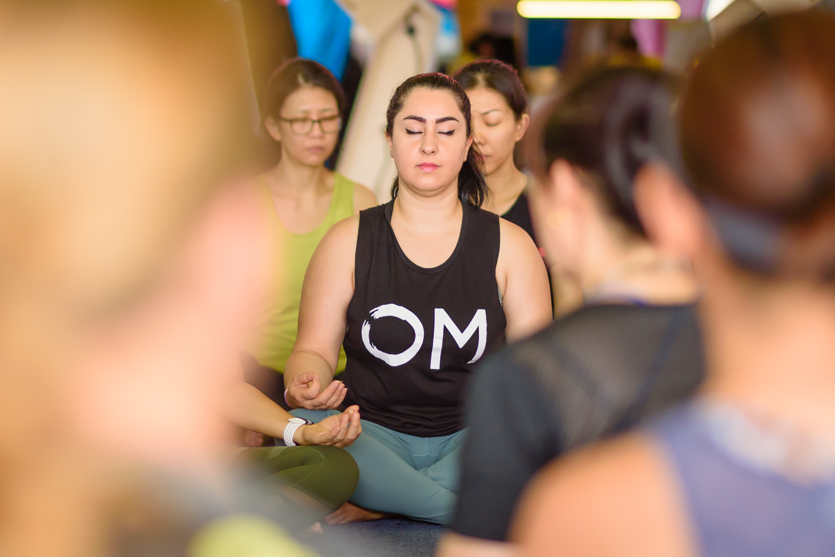
No human being who has walked this planet was or is different from others. -Paulo Kohl
Even the English translation “May all beings be happy and free” elevates our awareness to more conscious thought. We do not wish only for ourselves, but recognize we are part of a collective effort on this planet. If I wish myself these blessings, so too may I wish them on all others. This honoring of divinity within you calls onto this planet what we need, compassion. Recognizing we are all one, we can move into sincerer compassion for ourselves and those around us. According to Insight State, We cannot achieve true happiness if we cause unhappiness to other living beings, nor can we be free if we deprive others of their freedom. The mantra moves us into the one-heart space.
We must be cognizant of all beings on this planet and the affect our own actions have on them. When we recognize our personal impact on others, compassion arises and global kindness is the natural result.
4) Mantra: Soham (So’ Hum”)
Soham Meditation: The natural mantra which repeats itself in all of us.
Soham is Hindi.
Soham a mantra which is not needed to be repeated – because it is continuously repeating itself on its own – in all of us, along with our breathing. It is said that as long as this mantra keeps going on inside us, there is life in the body. As soon as it stops, we are no more.
In order to understand Soham, we have to look at our breathing process. During breathing we inhale air and exhale air. If we closely observe our breathing process, we will find that as our breath goes out and comes in, it produces two tiny sounds of syllables. The breath goes out with the sound ‘so’ and comes in with the sound ‘ham’.
Every time the breath goes out and comes in, one repetition of the Soham mantra takes place. Whether one is a Christian, a Jew, a Hindu or a Muslim, one repeats this mantra unconsciously thousands and thousands of times every day. The meaning of Soham is “I am that.” Through these two syllables, we contemplate our oneness with supreme consciousness. Through the ever going process of breathing, our ‘self’ keeps repeating the mantra – I am that.
Observing the Soham mantra is a natural Sadhana, a natural yoga. It is known as japa-japa, the unrepeated mantra repetition. Since Soham goes on within us all the time, we do not have to make an effort to repeat it. All we have to do is become aware of it. Since this technique is very subtle, we may have to practice it for a while in order to understand it.
5) Om Gum Ganapatayei Namah
Translation: I bow to the elephant-faced deity [Ganesh] who is capable of removing all obstacles. I pray for blessings and protection.
Modern adaptation: In Hindu teachings, Ganesh is known as the god of wisdom, success and the destroyer of obstacles. This is one of my favorite mantras to practice when I’m facing a big challenge or obstacle in life, and especially when I am traveling.
This mantra awakens Shakti, the manifesting energy of the Universe. It stokes the fire of transformation that resides within and is located at the root chakra.
“Om Gam Ganapataye Namaha,” can be loosely translated to “Yo! wake up root chakra, energy of transformation, so I can move through any obstacles in my life. Jai!”
Most importantly, we are calling upon the powerful energy of Ganesh, the elephant headed deity, who is widely revered as the “Remover of Obstacles and the Lord of Beginnings.”
According to Kundalini Yoga, Ganesh, also referred to as Ganapataye, resides in the first chakra, called Muladhara (muladhara). Mula means "original," and adhara means "foundation." The muladhara chakra is the principal origin from which the manifesting energy of Shakti resides within each of us. When we awaken that energy, it helps us move through all the other chakras with more ease in order to activate a strong sense of self, express Divine love, communicate clearly and connect with our own intuition.
This particular mantra is important because not only is it fun and catchy, but it also represents a willingness to release and move past the perceived obstacles in our lives. We can all make excuses about why we can’t achieve our dreams, but we will have an easier time succeeding when we choose to focus on our goals rather than our challenges. So when we make the choice to chant this mantra, we are aligning ourselves with our desired outcome and moving towards it with conviction and certainty.
I suggest using this mantra when we want to clear the Chitta Vritti, or the anxious chatter of the mind. We can repeat this mantra 108 times out loud using our mala beads, most importantly, we make it personal and find our true authentic voice... and have fun.
Remember, YOU are the co-creator of YOUR life!

My Mala BROKE! Now What?
“My mala broke, now what do I do?” This is a question I am asked quite often. I always say, “Congrats!”
I also understand that it’s usually a tough moment because we can become attached to our malas, having chanted and worn them for some time. But, according to the yogis, once your mala breaks, you no longer need that one. Meaning, the relationship and karma associated with the mala is complete. Now is a great time to celebrate the end of that connection.
I suggest taking some time for reflection after a mala breaks. Take a moment to re-read the meaning and energy that the stones or seeds on the mala represent. You can note how and why that particular stone (or seed/wood) showed up in your life when it did. Acknowledge on how the mala worked for you from the time you received it to the time it broke.
Did it break at a poignant time? Maybe it was a gift from someone who needed to be in your life at that time? Maybe now you embody the energetic property the mala offered? Ask yourself these questions and hear your own truth.
When your mala breaks, it’s a good idea to end your relationship with it, with palms together and head bowed. Do this with reverence as if you were making an offering, giving thanks and gratitude. It is not recommended to throw the broken mala in a drawer because you are going to get to it later, you don’t want the energy of a broken mala lying around. Remember how excited you were when you received the mala? It was the beginning of a new relationship, so have that same stance/energy as you complete and end this relationship.
You might take the mala apart and spread the beads around your garden or your home. Recycle the beads into another form, or bury it. Whatever you do, do it with gratitude and closure. I have also gifted some of my personal malas when I felt like they had served their purpose in my life. Malas can be a powerful and very personal tool that we can use along our yoga journey to manifest our dreams and live out our dharma. It’s your mala, your practice, your truth.

Sankalpa/ Intention Setting
Sankalpa (Sanskrit: संकl) means an intention formed by the heart and mind -- a solemn vow, determination, or will.
Your Sankalpa is a conscious articulation and desire with the focused intention of bringing something important into your life, either your outer or inner life.
Think about a short term or long term sankalpa —write a list of at least 3 that you would like to bring into being:

Now select one of these sankalpas and write down the steps you need to take for it to happen:

MALAS, MANTRA & MEDITATION
Tymi Howard, 500 E-RYT with Yoga Alliance, is an international yoga teacher,
certified holistic coach, creator of Manifest Yoga International and founder of Guruv Yoga Studios in the United States. Pioneering the Vinyasa and Yin Yoga movement not only in Central Florida, but throughout mainland China, SE Asia, and Indonesia. Tymi is dedicated to inspiring people to discover their life's purpose through the art of yoga.

www.tymihoward.com
Facebook Page: Manifest with Tymi Howard
Personal Facebook: Tymi Howard
Instagram: TymiHoward
Email: tymi.howard@gmail.com
Online classes: Daily Yoga App and www.yogavibes.com

